DATE: 27.09.2019
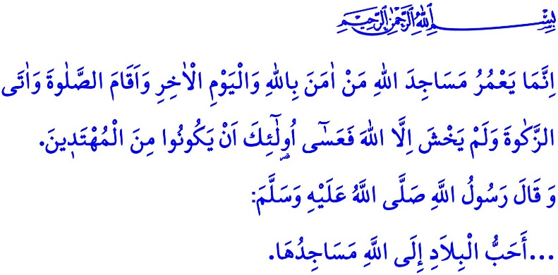
MOSQUESAND LIFE
Honorable Muslims!
In the verse I have just recited, the Almighty Allah (swt) states, “The mosques of Allah are only to be maintained by those who believe in Allah and the Last Day and establish prayer and give zakah and do not fear except Allah, for it is expected that those will be of the [rightly] guided.”
In the hadith I have just recited, the Prophet Muhammad (saw) says, “…The most beloved places on Earth to Allah are its mosques.”
Dear Believers!
The Islamic civilization is the one centered around the mosque. Mosques are holy places that have from the past to the present borne witness the social life itself and where the Islamic places develop and Muslims unite. The mosque is the heart of our residential areas, the spirit of our cities, and the safe haven for our noble nation and the Muslim ummah. They are not only places for worship, but also hubs where our history, literature, customs and traditions, and culture are intertwined.
Dear Muslims!
The Prophet Muhammad (saw) placed a special emphasis on building mosques and masjids. Upon the hijrah from Makkah to Madinah, he first of all, built the Masjid al-Nabawi. He turned Yathrib into Madinah, and the Masjid al-Nabawi into the cradle of science and knowledge. That way, the Prophet of Mercy actually designed a city model centered around the mosque and established strong ties between the mosque and the life. It was the Masjid al-Nabawi where he laid the foundation of the Islamic civilization that has, since the Asr al-Saadah, spread justice, wisdom, compassion, peace, safety and security, and knowledge throughout its reach. In the Suffa, a special section in the Masjid al-Nabawi, a group of young and self-sacrificing companions who devoted themselves to knowledge and worship turned out to be the forerunners of a benevolent generation. On one occasion, the Prophet Muhammad (saw) gave the good news that Allah would let those people whose hearts were connected to masjids enjoy the shade of the sky on the Last Day.In this regard, he encouraged Muslims to enhance and improve mosques that are the apple of the eyes of cities by saying, “Whoever builds a masjid for Allah, Allah will build for him a house like it in heaven.”
Dear Believers!
Just as we need to eat, drink, and work, and just as they are significant, it is also necessary and valuable to center our lives around mosques. This is because mosques are exceptional places where we can listen to our own self in the rush of the daily life, and under the domes of which we can submit our servitude to Allah (swt). They help us as Muslims strengthen our brotherhood and consolidate our unity and togetherness. They are blessed places that unite our bodies, as well as our hearts, as clear of all kinds of self-centeredness. Mosques, for all of us, are sometimes places of peace and tranquility, and sometimes sources of hope and consolation.
Dear Muslims!
The sound of adhan rising from the minarets does not only call us to performing prayer five times a day. Mosques, together with their adhan, minaret, dome, mihrab, and minbar, invite people to servitude, worship, piety, knowledge, and good morals as well. Then, Muslims, who submit their servitude to Allah (swt) by standing in prayer, should be aware that He oversees them outside mosques as well. Standing side by side in the same row with iman and ikhlas, they are responsible to protect and take care of their brotherly relations. Muslims, who enhance and improve mosques, also protect and beautify the environment they live. They do not damage a growing plant by itself, nor do they harm an ant in pursuit of its own sustenance. Muslims, who keep their mosques clean, also keep clean the world, the entirety of which is made a masjid by Allah (swt).
Dear Muslims!
How sad it is that today, when we are taken down by getting isolated and alienated, our mosques are gradually losing their position of being the heart of cities. However, the only places that will welcome us, like a compassionate mother's embracing her child, are our mosques. Our exhausted souls will rest in mosques, our spirituality will get stronger in mosques, and the answer to our search for the meaning of anything will be found in mosques.
Then, come! Let us center our lives around the mosques again. Let us take a break from our busyness during the prayer times, whether we are a superior or a subordinate, an employer or an employee, a business owner or a student of any walk of life. Let us all, women or men and children and old people, go to mosques and flourish in mosques. Let us not leave our mosques unattended and abandoned. Let us attain true peace by standing for prayer in mosques for Allah (swt). Let us not forget that mosques are in the center of life and full of life.
Dear Believers!
As in each year, this year, too, the week of 1-7 October will be celebrated as “the Mosques and Religious Officials Week”. We will share with our society the meaning and values added to our life by the mosques and religious officials through this year's theme "Mosques and Life". We will remember with gratitude our charity-loving nation's sacrifices to enhance and improve our mosques.
I would like to take this opportunity to wish Allah's mercy upon the deceased religious officials, who guide our life starting with adhan and ending with salah, and the deceased members of our congregation, which is the most valuable asset of our mosques, and to wish health and a long life for those alive yet. May Allah never leave our homeland without mosques, our mosques without congregation, and our minarets without adhan.

Tawbah, 9/18.
Muslim, Masajid, 288.
Muslim, Zakat, 91.
Muslim, Zuhd, 44. General Directorate of Religious Services

